**Project Design Phase-II**

**Data Flow Diagram & User Stories**

|  |  |
| --- | --- |
| Date | 03/10/2022 |
| Team ID | PNT2022TMID52021 |
| Project Name | Personal Assistance for Seniors Who Are Self- Reliant. |
| Maximum Marks | 4 Marks |

**Data flow Diagram:**

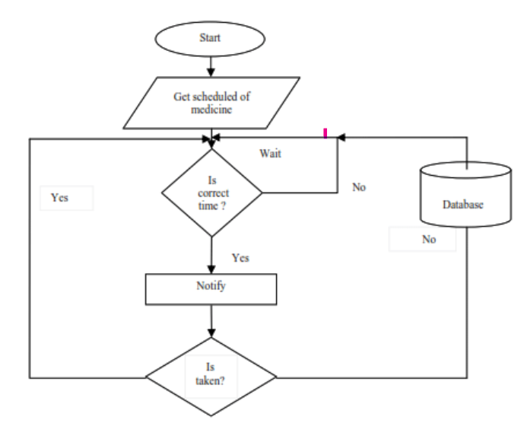

**User Stories**

|  |  |  |  |  |  |  |
| --- | --- | --- | --- | --- | --- | --- |
| **User Type** | **Functional**  **Requirement (Epic)** | **User**  **Story**  **Number** | **User Story / Task** | **Acceptance criteria** | **Priority** | **Release** |
| Customer (citizen) | Registration | USN-1 | As a user, I can register for the application by confirming OTP and access manually | I can access my account . | High | Sprint-1 |
| Customer (Doctor) | User Requirements | USN-2 | As a user, I want to monitor patients health. | I can receive  Confirmation email & click confirm. | High | Sprint-1 |
| Customer (Care takers) | Confirmations | USN-3 | As a user, I can register and confirm throughe-mail OTP. | I can register & access the dashboard with  FacebookLogin. | Low | Sprint-2 |
| Customer  (Elderly people) | Payment options | USN-4 | As a user, I can pay through Cash on Deliveryor else with Credit/Debit card. | I can register or pay  through login Dashboard. | Medium | Sprint-1 |
| Customer  (Disabled people) | User Requiremen  -ts | USN-4 | As a user, I need to take my medicine with the help of vibrations. | I can take my medicines with the help of notifications | High | Sprint 3 |